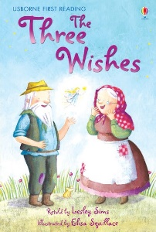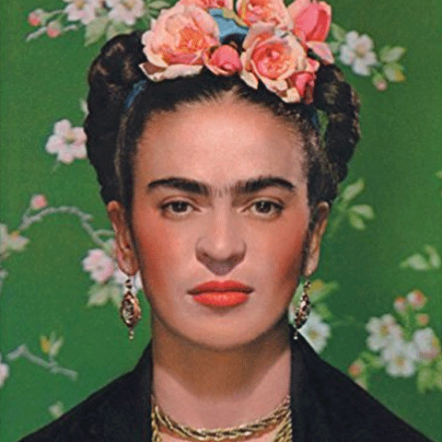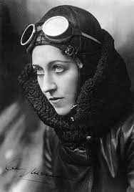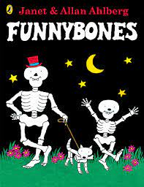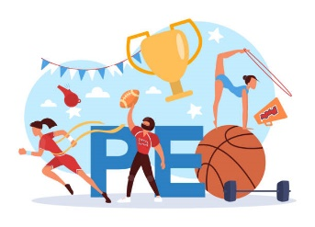

As authors, we will be…reading a number of picture books, including Janet and Allan Ahlberg’s Funnybones, and poems. We will predict events, ask and answer questions and consider the characters’ feelings as well as considering how the senses are used in different settings. We will us Standard English and noun phrases to write descriptive sentences, newspaper reports, labelled diagrams, non-fiction reports and poems.

As mathematicians, we will….have a busy term learning about money, multiplication, division, addition and subtraction but first we will start with place value. We will build on our skills learned previously by counting, ordering, and representing numbers to 10 (year 1) and 100 (year 2) in a variety of ways.

In PE, we will be… improving our multi-skills, which includes movement, balance, reaction, coordination and timings. We will also be learning about attacking and defending games.

PE in on Tuesday and Thursday for the first half term.

As historians, we will be…. learning all about the life and accomplishments of Amy Johnson. We will explore the history of aviation and understand where these events take place within a chronological order.

The Gulls Class

Autumn Curriculum Overview 2024

As philosophers, we will be… exploring what it means to be unique, focusing on what it means to belong and enquire how a faith member has a sense of belonging to their faith.

Our Christian Values this term are Generosity, Thankfulness, Compassion and Trust

As scientists, we will be… learning about animals, including humans. By the end of this unit we will be able to name the main parts of the human body, understand the importance of keeping healthy and be able to describe and compare animal families and the structure of a variety of common animals.

As artists, we will be…. learning about portraits and use of different materials and techniques when making our own. We will also have the opportunity to explore the work of Pablo Picasso, Paul Klee, Henri Matisse and Frida Karol, and create artwork inspired by them.